**Kali Linux Basic Commands**

# **1. Date Command**

In Kali Linux, the 'date' command is used to display the system date and time. In order to display the date, we have to use the following command:

**Syntax:**

1. # date



# **2. Cal Command**

The cal command displays the current month's formatted calendar on our terminal screen. If we require a more advanced version of cal, we can install the ncal package on our Linux machine, which displays the calendar vertically and provides additional options.

**Syntax**

1. # Cal

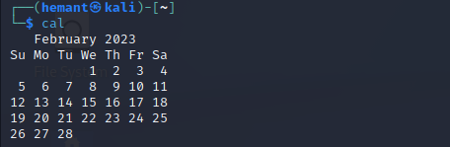

# **3. Cd Command**

The 'cd' command is also called chdir (Change Directory). We used this command to change or switch the current working directory.

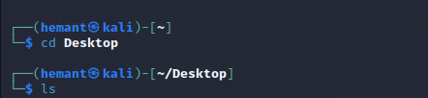

# **4. cp Command**

In Kali Linux, the 'cp' command is used to copy files or a group of files or directories that create an exact image of a file on a disk with a different file name.



# **5. whoami Command**

The 'whoami' command is used to print the effective user ID whereas the who command prints information regarding users who are presently logged in.

The "w" command can also be used to view who is logged on and what they are doing.

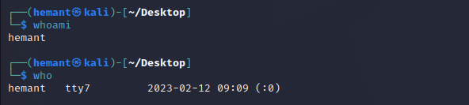

# 6**. Ls Command**

One of the most useful commands in Kali Linux is the 'ls' command. The ls command lists the directory contents of files and directories. With the help of the ls command, we can easily list out every hidden file of a directory with the -a attribute, and for more detailed output, we can use the -l attribute.

Syntax

1. # ls -al

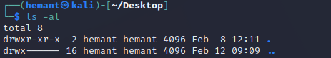

# **7. Cat Command**

The 'cat' (concatenate) command is one of Kali Linux's most commonly used commands, permitting us to create single or many files, concatenate files and redirect, view contain of file output in terminal or files.

Usually, we use the cat command to display the content of a file.

1. # cat filename

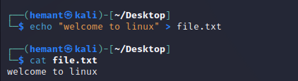

# **8. mkdir Command**

The 'mkdir' command is used to create directories. For example, if we wish to create a directory named 'Penetration testing' under the 'Documents' directory, then we have to open a terminal and enter the below command:

1. cd Documents
2. mkdir Penetration testing

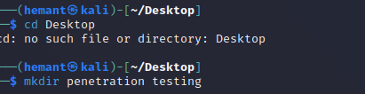

# **9. rm Command**

In Kali Linux, the 'rm' command is used to delete files. It can be used to delete directories when we use t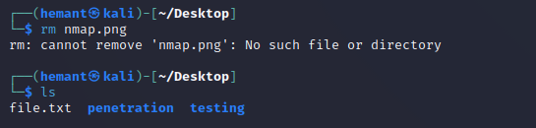mv hem recursively.

# **10. mv Command**

With the help of the 'mv' command, we can move or renames files and directories on our file system.

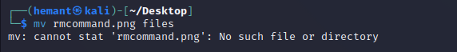

# **11. uname Command**

The 'uname' command displays the current system's information. We can view system information about our Linux environment with the uname command in Linux. With the uname -a command, we can learn more about our system, including Kernel Name, Node Name, Kernel Release, Kernel Version, Hardware Platform, Processor, and Operating System.

**Syntax**

1. # uname

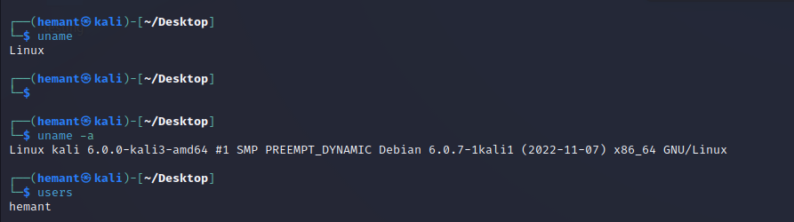

# **12. uptime Command**

The 'uptime' command displays the amount of time the system has been running. Uptime's basic usage is simple: simply type the name of the command and click Enter.

Use the -p command-line option if we merely want to know how long the system has been up for and in a more human-readable format.

Syntax

1. # uptime

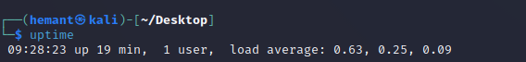

# **13. users Command**

The 'users' command is used to display the login names of users logged in on the system.

Syntax

1. # users



# **14. less Command**

In Kali Linux, the 'less' command is used to view files instead of opening the file. The less command is a more powerful variant of the "more" command which is used to show information one page at a time to the terminal.

We can view any text file with the help of the "less" command simply by typing the following command into a terminal window:

**Syntax:**

1. # less /etc/passwd

15

**15.more Command**

The

"more"

command permits us to show output in the terminal one page at a time.

This is particularly beneficial when using a command that requires a lot of scrolling,

such as the '

ls'

command or the

'du'

commands.

The

'more'

command works with any applications that output to the screen. A good

way to test this is to type the following command into a terminal window:

Syntax:

1.

# moreetc/passwd

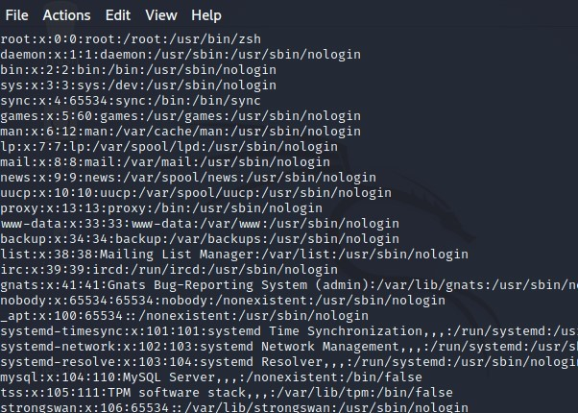

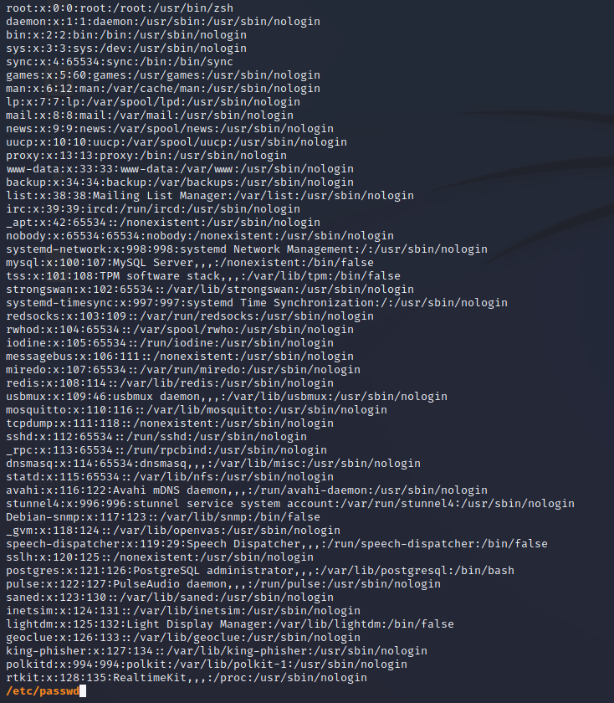

# **16. vi Command**

The 'vi' editor is a screen editor that comes with practically every UNIX system. The command mode and the insert mode are the two most common nodes in vi.

In order to start entering text in an empty file, we have to first switch from the command mode to the insert mode. To accomplish this, start typing the letter i. When we start typing, anything then the type will be entered into the file.

Type some short lines, then press Return at the end of each. Vi does not use word wrap like other word processors. It will break a line at the screen' edge. If we make a mistake, we can undo it by pressing the Backspace key. If the Backspace key on our computer is not working, then try the ctrl + h key combination.



17

**. free Command**

In Kali Linux, the

'free'

co

the

amount of RAM

availabl

of

physical memory

used an

buffers.

Syntax:

1.

# free

If we use the

free

command

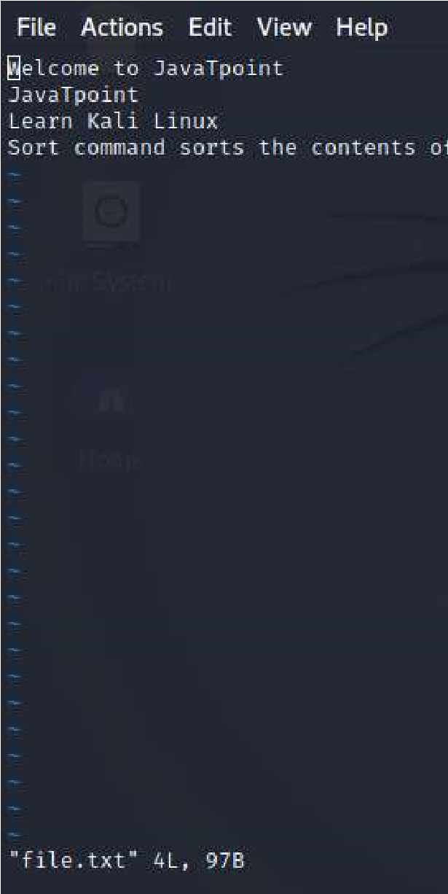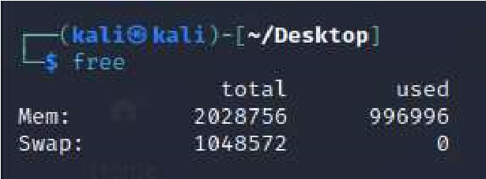

mmand provides us the

useful inform

e on a Linux machine. It also displays the e

d available space, as well as

swap memor

with the

-

t

opt

ion, it would list the total line

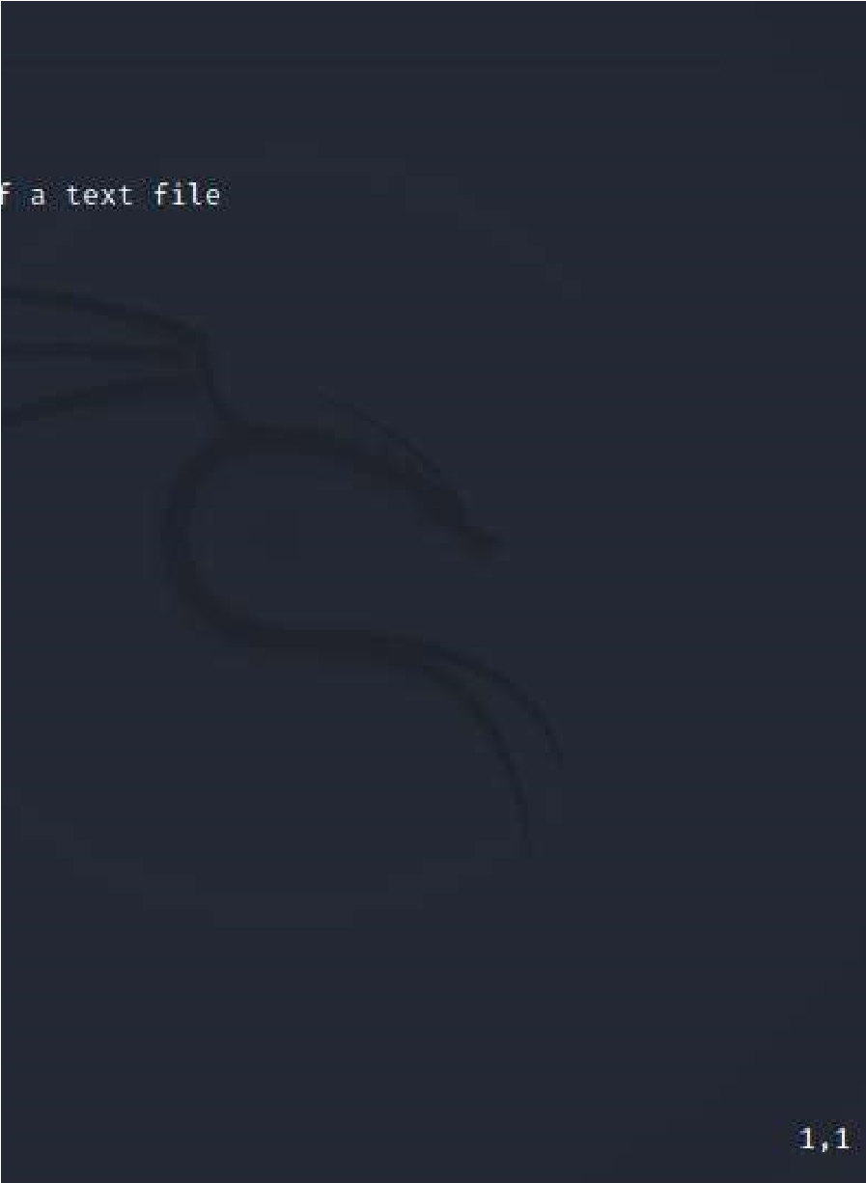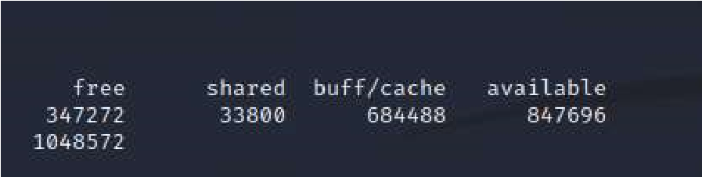

ation about

ntire amount

y

with

kernel

at the end.



# **18. sort Command**

Using the 'sort' command, we can sort the content of the text file, line by line. Sort is a standard command-line program which prints the lines of its input or concentration of all files listed in its argument list in sorted order.

Syntax:

1. # sort file name

We can reverse the order of any file's contents by using the -r sort.

Syntax

1. # sort -r

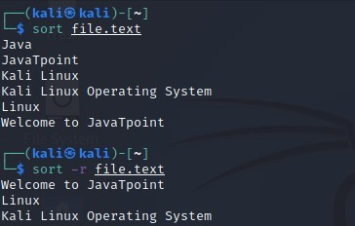

## **19. history Command**

The 'history' command is one of Kali Linux's most commonly used commands. The history command in the bash shell saves a history of commands entered that can be used to repeat commands.

We can run the history command by itself, and it will just print the current user's bash history on the screen, as shown below:

Syntax:

1.

# history

**20**

**. Pwd Command**

In Kali Linux, the

'Pwd'

com

information about the direct

access the directory while in t

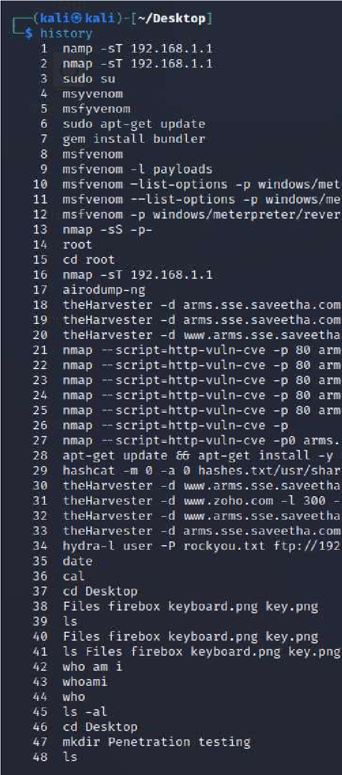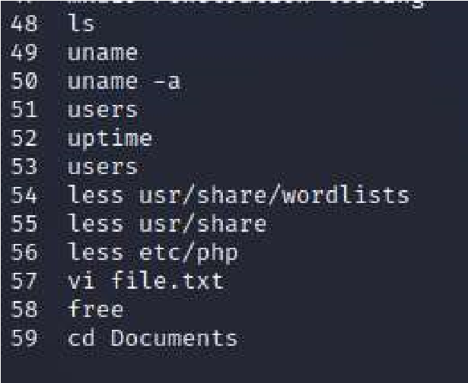

mand is used to

print working director

ory we are now in. This is especially useful i

he middle of a complicated

process.

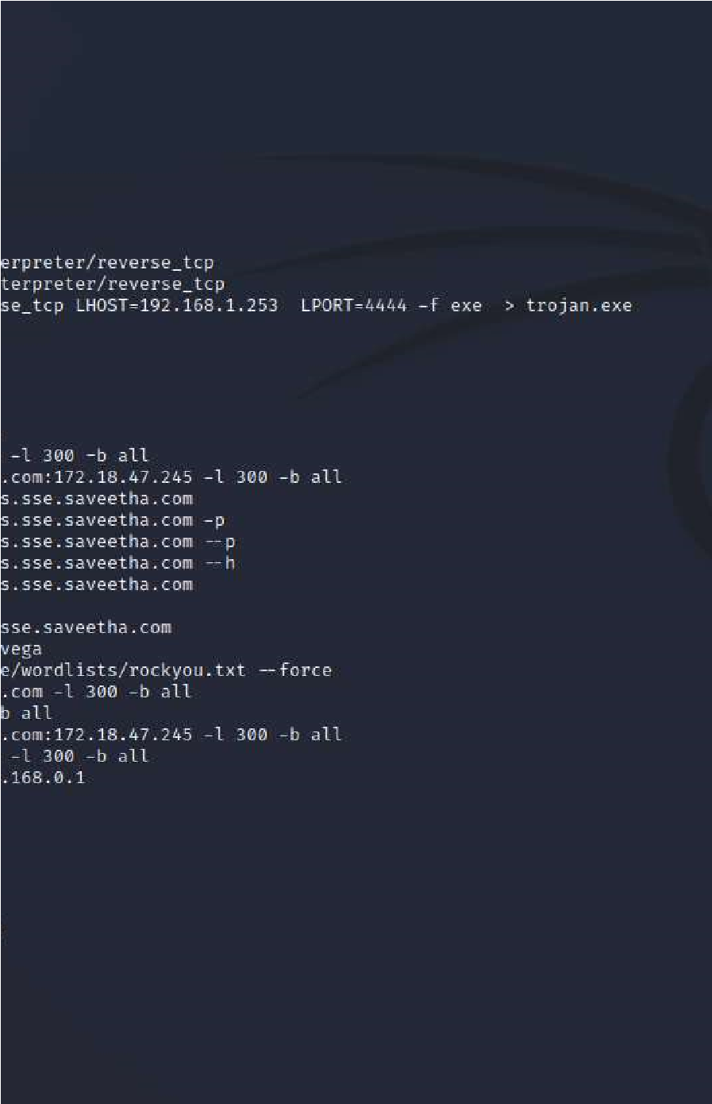

y.

It gives us

f we need to



